SANCTUARY RESTORATION UPDATE. OCTOBER 25, 2022
The State Historic Preservation Office application for 50% matching funding for the completion of the sanctuary became available today and must be completed and submitted by December 2, 2022. The John Canning Company will complete the decorative work in the apse and on the walls and will oversee the subcontractors. The scope of work and the budget negotiations with Canning was concluded this week and it was brought to the trustees meeting where it was given final approval.
Even though a formal sanctuary fund-raising campaign will not begin until the SHPO grant is secured, the Sanctuary Fund continues to accept donations. If donating to the Sanctuary Fund in 2022 (versus 2023) is advantageous to your tax situation, please consider contributing before the end of this year. A $1 for $1 match for the next $9K donated to the Fund is currently available - which will double the impact of any gift (large or small).
In faith,
The Sanctuary Committee
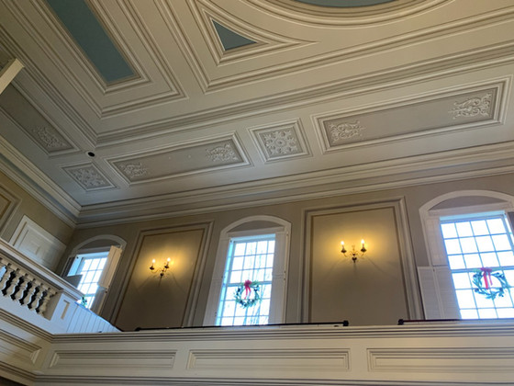
Quote of the month: “Places of worship reflect the values of a community and are important social symbols”.

